* Time tracking
  + For work on tasks, register time on task
    - You will find it in the tab *“Time”* for each task item in VSTS  
      
  + For meetings, discussions and other types of work
    - go to “*Timesheet”*:  
      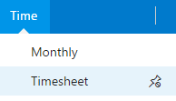
    - then click *“New time”*
    - Find discussions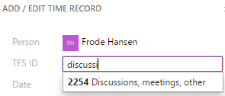
    - Remember to write details in comment field